Tutorial for Finding Invoices under your Profile on the ACEC-Iowa website
- Click on – My profile at your log in home page
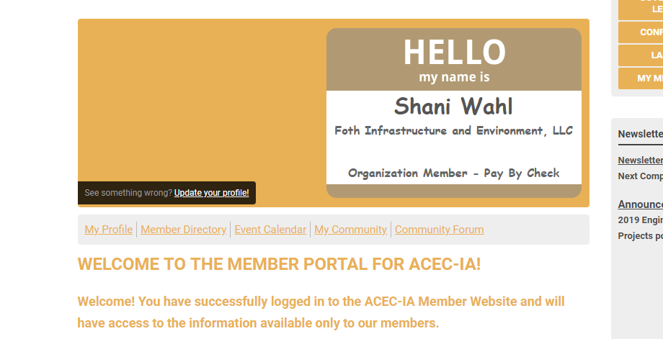

- Click on My profile (again)
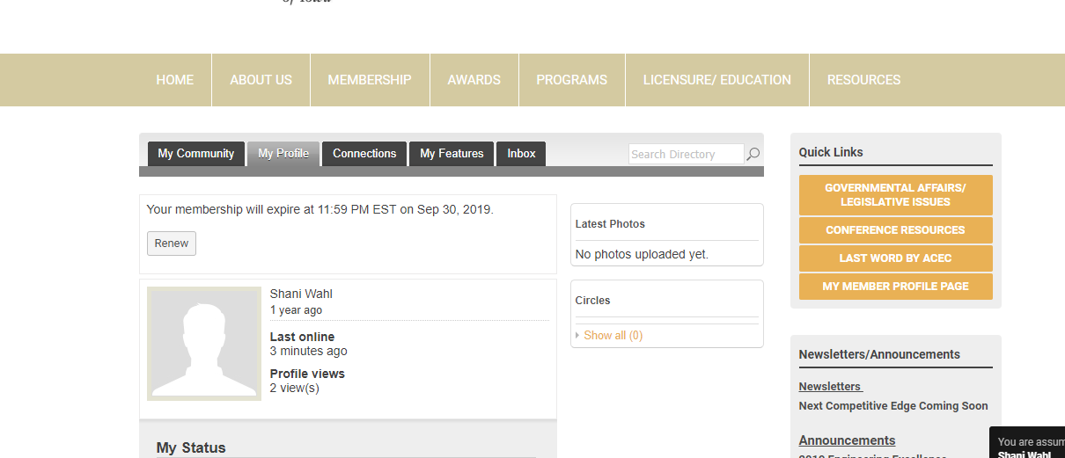

- Click on Invoices
